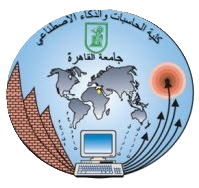

**Cairo University**

**Faculty of Computers and Artificial intelligence**

**IS211: Introduction to Database Systems**

**Super Market (Phase 1)**

**TA: Eng. Alia Magdy**

**Team Members:**

* Mariam Badr Yehia Abd El-Naby (S20) 20230391
* John Ayman Demian (S20) 20230109
* George Malak Magdy Nashed (S20) 20231042
* Marawan Mohammed Badr (S20) 20231157
* Mohammed Atef Abd El-Kader (S20) 20231143

**Supervised:**

**Dr. Ali Zidane El Qutaany**